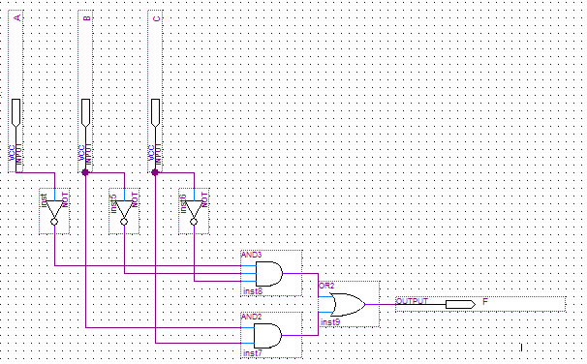
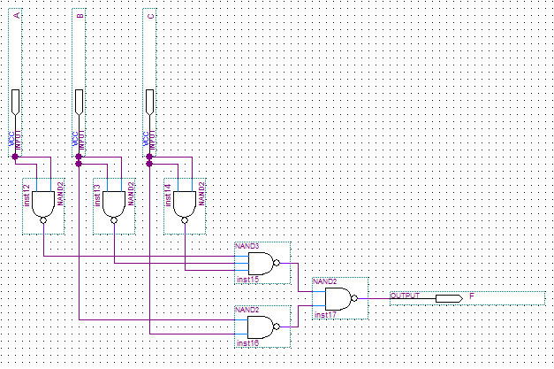
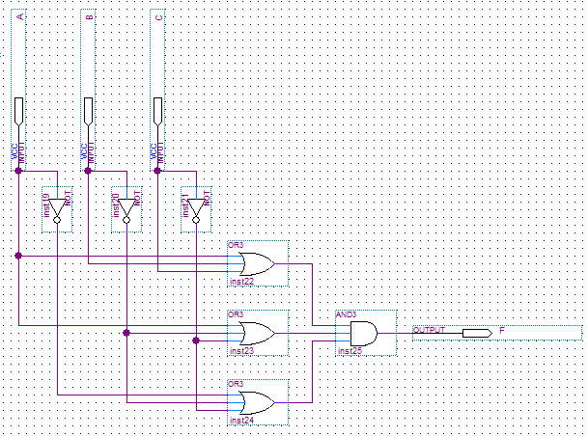
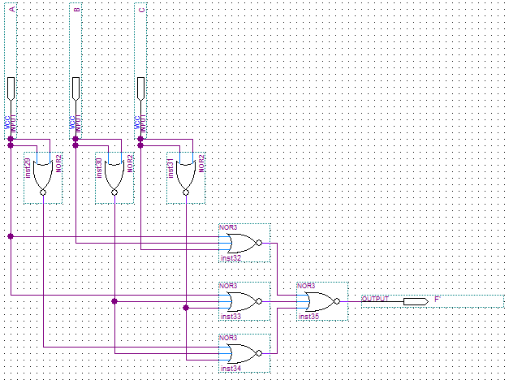
Digital Design Lab 4
Tara Moses
Section L001
October 12, 2015
tsmoses@uark.edu
Abstract
The purpose of this lab was to program a 7-segment display to show the letters A, b, C, d, E, and F for the binary inputs corresponding to decimal numbers 10 through 15, respectively. A function was programmed using Quartus to complete this task, and the program was tested using the 7-segment display and four input switches on the FPGA board.
Introduction
A 7-segment display is a common device used in digital clocks as well as other electronic devices that need to display numbers. It involves seven different lights, or segments, that can be programmed to light up individually depending on the inputs. The segments were labeled A through G, with A being the top light, and B through F continuing around in a rectangle clockwise. G represented the segment in the middle. Each segment lit up when its input was a 0, and was off when presented with a 1. For this lab, we used Quartus II to program an FPGA board that included a 7-segment display. Quartus II is software that can be used to create circuits as well as write programs using the VHDL language.
This lab was designed to program a 7-segment display to display extra input combinations. A single-digit hexadecimal number can be represented in binary using four digits. For this lab, in order to display all 16 input combinations for a single-digit hexadecimal number on the 7-segment display, four input switches on the FPGA board were used.
Design and Implementation
In this lab, existing code was given for the 7-segment display to display numbers 0 through 9. For each input combination, there was a line of code similar to the one below.
WHEN "XXXX" => leds <= "ABCDEFG" ;
For this line, XXXX refers to the binary input combination and ABCDEFG refers to the binary output of each segment. For each letter in the binary output, 0 indicated a lit-up segment, whereas 1 indicated a segment that was off. The full code for this lab is shown below.
ARCHITECTURE Behavior OF seg7 IS
BEGIN
PROCESS ( bcd )
BEGIN
CASE bcd IS ------ abcdefg
WHEN "0000" => leds <= "0000001" ;
WHEN "0001" => leds <= "1001111" ;
WHEN "0010" => leds <= "0010010" ;
WHEN "0011" => leds <= "0000110" ;
WHEN "0100" => leds <= "1001100" ;
WHEN "0101" => leds <= "0100100" ;
WHEN "0110" => leds <= "0100000" ;
WHEN "0111" => leds <= "0001111" ;
WHEN "1000" => leds <= "0000000" ;
WHEN "1001" => leds <= "0001100" ;
WHEN "1010" => leds <= "0001000" ;
WHEN "1011" => leds <= "1100000" ;
WHEN "1100" => leds <= "0110001" ;
WHEN "1101" => leds <= "1000010" ;
WHEN "1110" => leds <= "0110000" ;
WHEN "1111" => leds <= "0111000" ;
WHEN OTHERS => leds <= "1111111" ;
END CASE ;
END PROCESS ;
END Behavior ;
This code, when uploaded to the FPGA board, allowed the 7-segment display to show the letters A, b, C, d, E, and F for inputs corresponding to decimal numbers 10 through 15.
Results
The 7-segment display successfully displayed the correct symbol for each input combination (decimal numbers 0 through 15). The lab took about 45 minutes to complete.
Conclusion
The lab was designed to program an FPGA board to display correct symbols for a 7-segment input. By editing existing code, the 7-segment display was ableto display letters A, b, C, d, E, and F. The lab was successful. In the future, the skills learned in this lab could be applied to bigger projects, such as displaying more than one digit using multiple 7-segment displays.

